WHAT’S GOING ON?
June
3 Graduate Recognition Banquet
9-15 Mpact Mission Trip
14 Senior Adult Fellowship – 10 am
17 Father’s Day 24 Business Meeting
28 Senior Adult Fellowship – 10 am

July
4 Independence Day
TBD Youth Camp – Highland Lakes
12 Senior Adult Fellowship – 10 am
14 Local Mission Project 15 Business Meeting
26 Senior Adult Fellowship – 10 am
29-Aug 3 VBS
August
29-Aug 3 VBS
9 Senior Adult Fellowship – 10 am
19 Business Meeting
23 Senior Adult Fellowship – 10 am
Dear Church Family,

Calling All People to “Work-It-On-Out”

JOIN US for workout classes. We meet Monday (6:30-7:30), Wednesday (6-7), & Thursday (6:30-7:30) in the fellowship hall. We have two groups… Tae Bo & Zumba for those who are slightly more fit & Richard Simmons for the rest of us!! We work at our own pace. No equipment needed. Come for fun, laughter, & fellowship!!

Mpact Mission Trip

June 9th to 15th

Journey Youth Camp

July 9th to 13th or July 23rd to 27th are the only dates still available. We need to get sponsors & get our money in ASAP if we want our youth to attend.

Vacation Bible School

July 29th to August 3^{rd –} Please contact
Cheryl Franklin for more info or to volunteer.
Teachers & volunteers are still needed!

Just for Laughs

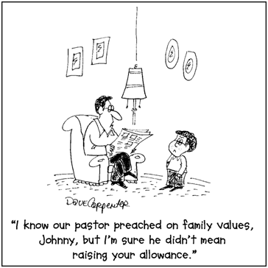

Four Years – It’s hard to believe that four years have come & gone since God called our family to KSBC. It seems like only yesterday we were getting settled & adjusting to country life. I thank you from the bottom of my heart for embracing me & loving my family into your family at Knobbs Springs. I appreciate your patience with me as a pastor & as an individual. We consider you family & people that we love. Relationships are what ministry is all about, & we thank the Lord for you & our time serving you at KSBC.

Loving People – Imagine… what would happen if more people understood that church isn’t just a building or set of cool programs, but people on a mission to share love & hope. In Jesus’ final instructions to his friends, he said this, “a new command I give you: love one another. As I have loved you, so you must love one another. By this everyone will know that you are my disciples, if you love one another.” (John 13:35) There is probably no better measure of a person’s connection to Jesus than seeing how that person loves, so we’re reaching for more of God’s love as we do life together. Jesus also told us to “go & make disciples of all nations,” (Matthew 28:19). (Go & Be) We can’t just keep what he gives for ourselves. We’re inspired to go… where people are, & instead of inviting them to come to us, we hope to bring the church to them — in our neighborhoods, coffee shops, at work, & especially to the ones at the margins, the hurting, the sick, the poor… And we hope that if we do better in sharing our resources, we can see God’s kingdom come far beyond our borders, in our own community & even in other nations.

Everyone Plays a Part in the Church – When a band plays, does everyone play the same instrument? No. Different people play different instruments as well as different notes at different times to create a beautiful song. The children of God are like a band. We all have different parts to play in order to accomplish our goal. Nobody here plays a solo. Find your place to serve & use your gifts & talents for the building up of the church. The more you serve, the more you are blessed & the more those around you are blessed.

The Economy & Churches – Giving has been good in 2012. We are approaching the summer months which are usually some of our most expensive months. Summer youth activities, higher utilities & water costs always hit us hard financially. When people don’t tithe or even when some slack off, others suffer & have to take up the slack. A plea from your pastor, don’t neglect to give during the summer months! We need you to continue to be a part of the ministries that will take place during the summer. I believe in faith you cannot out give God & that He rewards those who cheerfully give.

Summer Activities – Our annual MPACT Mission Trip will be June 9-15 in Irving, Texas. Journey Youth Camp at Highland Lakes is still TBD. We still do not have adult sponsors who have stepped up yet. Without sponsors our youth will not be able to attend. If you are interested in being a sponsor for camp, please let me know as soon as possible. VBS is an annual mission opportunity for our church to reach out to our community & to share Jesus with children. Don’t miss out on the opportunity to be used by God in our many important summer outreach ministries. Vacation Bible School is scheduled for July 29 – August 3. We need your help! VBS will begin nightly at 6:00 p.m. preceded by a meal that will be served each night at 5:30 p.m. for all workers. The last night of VBS, August 3, will be a family night filled with awards, prizes, music & games. Plan to be a part of these special weeks of summer.

Special Thanks – I want to personally thank Curtis Waggoner for heading up the Building & Grounds Team & all the fixing up, cleaning up & touching up they did around the church. I want to thank Jack Ruthven for all the door, tile, trim, & attic work he has done over the past several weeks as well. For all who did yard work, worked in the flower beds, painted the inside & out, & the general cleanup around the church, I say thank you for a job well done. I want to say thanks to everyone who helped the two Saturday workdays in May to get the church looking good for the homecoming weekend. Make sure you tell these folks thanks when you see them.

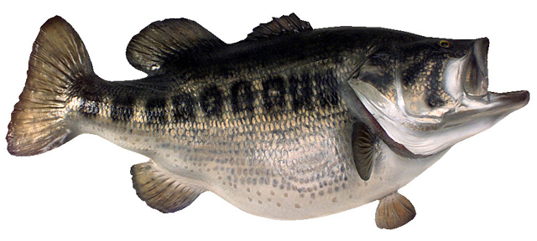
I pray the Lord’s richest blessings on you & your family.

In Christ,

Brother Mark 512-229-6555 ~ Txloves2fish@yahoo.com

